Instructor:

Dr. Mostafa El Mokadem

**[Salma Tharwat] [3787] [CCE]**

**[Nayera Abd El Samie] [4032] [CCE]**

**[Aliaa Abbas] [3747] [CCE]**

**[Essraa Hussein] [4375] [CCE]**

**Elegance Atelier**

Specialized Scientific Programs

Specifications and Feasibility Studies

(Spring 2018)

Faculty of Engineering

University of Alexandria



Fashion is ART and you are the CANVAS…

# Excutive summary:

This is a proposed plan for a professional soiree atelier in Egypt, initially in the city of Alexandria, Why specifically this city?? Because Alexandria is the perfect combination between modernism and the old culture.

Our project will provide as an initial phase a mini workshop located in “Kafr Abdu”; where most of the targeted category of customers live. That way it would be more easily accessible.

The mini workshop will speedily grow to be a huge company with its well-known worldwide brand soon it will have its own fashion show that will be made all over the world especially in the city of fashion (France). Moreover, it will not be restricted to soiree only but also all kind of clothes, however how that will happen? And what is the special features that will make it different from other ateliers? We will cover up all these questions in the following…

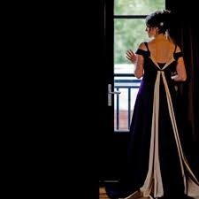

**Figure .1**

# Overview:

Elegance is an Egyptian brand that will be established by a group of ladies in 2018. The company activity will start by producing soiree dresses and will successfully be a prominent player in the creative industry ever since its launch. The atelier will be launched of genuine passion for design coupled with a great intention to preserve detailed elegant dresses and showcase its beauty.

## VISSION, MISSION AND GOALS:

Vision:

*“A better interaction with life”*

Elegance atelier aims to develop a collaborative movement which will transform social and environmental standards in the fashion industry within a short period of time.

Mission:

*“What you wear is how you present yourself to the world”*

Elegance brand is a fashion soiree brand dedicated to providing its customers with high quality dresses that suits all styles. Elegance main focus is restoring the sophisticated and classy look and preserving it for the coming generations making use of all its detailed elements in an overall fashion looking unparalleled design.

Goals:

* The eradication of exploitation, hardship and environmental damage from the supply chains to the fashion industry and the practices of fashion businesses.
* The raising of customers awareness in relation to elegant fashion.
* The creation of a model and precedent for fashion industry change which can be drawn from and built upon by other fashion companies.

# legal study:

We chose Limited partnership (A group of ladies) to be easily established and as the startup capital required for the project is not a lot.

Composed of One general partner and three limited partner

, Little governmental regulation, Flexibility and Taxation.

**Requirements:**

Health Department Permits

IDs of all partners

Bank statements for all Partners

Taxing Statements of partners

Contracts for all Heads and employees

Photocopies of valid professional practicing License

Photocopies of IDs

**Some of legal issues:**

* Financial aspects:

We handle it as our products are needed and supported by customers. The startup capital will be fully funded by the partners.

# organizational study:

* The 4 Founders.
* Main Taylor
* Head of Technical & Financial
* Head of Marketing & Sales
* Head of Public Relations
* Head of Human Resources

# Marketing study:

**SWOT ANALYSIS:**

|  |  |  |  |
| --- | --- | --- | --- |
| **S**  Strength | **W**  Weakness | **O**  opportunity | **T**  Threat |
| -Service quality | -Designing and Manufacturing is naturally timely. | -Growth rate | -High competition |
| -Good location |  | - Progress in fashion in Egypt |  |
| -original products customized to client preferences |  |  |  |
| -Reliability |  |  |  |
| -Relatively economical |  |  |  |

**MARKETING:**

**Marketing Plan:**

*Our marketing campaign will take places through various methods:*

*1- Social Media*

No one these days can underestimate the power of social media and the impact it has on the consumers’ behavior. We see large companies trying to associate themselves with large communication and advertising firms to attract the right crowd and communicate better through social media. We intend on breaking all grounds, by being available for our consumers on daily basis through Facebook, Instagram, Twitter and Snap chat. Any new features, offers, news or system updates will be communicated through all above mentioned platforms.

*2- Loyalty Cards*

No company can operate without its loyal customers and it is our job to maintain and grow that crowd. Therefore, special loyalty cards, thank you packages and offers will always be provided for the people who have devoted their time to helping us grow and enhance the business.

*3-More Ads.*

Part of the budget allocated for tv advertisements and posters specified when we talk about the financial study.

# Technical study:

## Technology and Operating systems:

To preserve Originality of the products the orders will be custom handmade to the wished of each client, this requires minimum automated Technology and more talented workforce

## Location:

We chose this location because the targeted category of customers mainly live there, besides Kafr Abdou considered as center of the city.

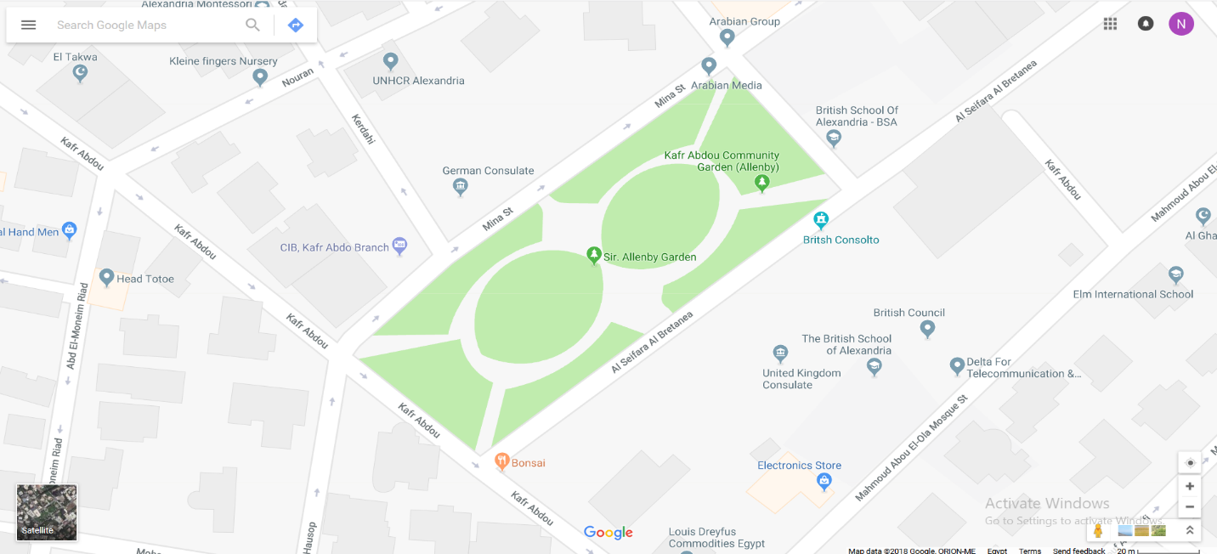

**Figure .2** Location on map

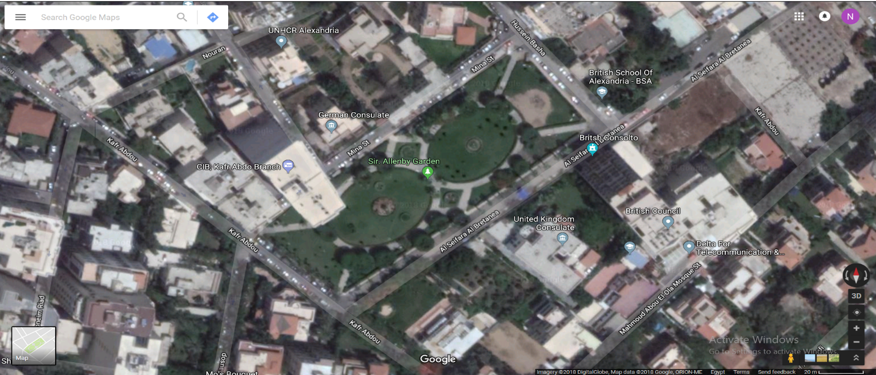

**Figure .3** Location on satellite

**Resource Availability:**

The materials required for manufacturing of clothes are expected to be fund with abundance, special material (eg: Silk) are to be discussed with each individual client according to their preferences and budget.

**Infrastructural Condition:**

As the premises are to be held in a newly built building the infrastructural conditions referring to the state of the premises can be judged to be of perfect condition as it has never been used before, transportation to and from the Atelier will be fairly easy as it is located at the heart of the city and within short distance of all three main sources of transportation there (Tram, Main Road [Abu Eir ]).

**Costs & Construction Requirement:**

The only costs are those of the rentals of the premises which are expected to be around L.E10,000 per month given the space and price of metre rental in the area.

# Finantial study:

**Investment Costs:**

* All Costs Estimated in L.E *

|  |  |
| --- | --- |
| Insurance for Atelier Rentals  (one-month rental) | 10,000 |
| Sewing Machines  (5 machines*4500/machine) | 22,500 |
| Electronic Equipment | 20,000 |
| Security System | 10,000 |
| Software System | 5,000 |
| Interior Preparation | 100,000 |
| Furniture | 40,000 |
| Paperwork Costs | 10,000 |
| Project Insurances & Preliminary Taxes | 40,000 |
| Total Investment Costs | **257,500** |

**Annual Running Costs:**

* All Costs Estimated in L.E *

|  |  |
| --- | --- |
| Materials** | *924,000* |
| Equipment Maintenance | 5,000 |
| Premises Maintenance | 2,000 |
| Software Maintenance | 1,000 |
| Employee Uniforms  (20 employees*150/uniform) | 3,000 |
| Material Shipping  (12*1000 per monthly ships) | 12,000 |
| Water and Electricity | 3,000 |
| Total | **950,000** |

**\*\* Material Cost Estimation:**

**\* Main Materials \***

Estimated 15 customers/day = 450 customers/month = 5400 customer/year

Estimated ~2 meters of materials per order = 10,800 metre/year

Estimated Average of L.E 80/metre = 864,000 L.E/year

**\* Accessories \***

Estimated 5000 L.E/Month for buttons, clips, etc.. = 60,000 L.E/year

**\* Total \***

L.E 864,000 + L.E 60,000 = L.E 924,000

**Annual Rentals:**

|  |  |
| --- | --- |
| Atelier Rent  (12* 10,000 L.E/month) | 120,000 |

**Annual Salaries:**

|  |  |
| --- | --- |
| (Main Taylor * 2300/month) | 27,600 |
| (4 Managers * 2000/month) | 96,000 |
| (4 Taylors * 1800/month) | 86,400 |
| (5 Employees * 1500/month) | 90,000 |
| Total | 300,000 |

**Marketing Cost:**

* All Costs Estimated in L.E *

|  |  |
| --- | --- |
| Social media Ads  (2 media: fB + Instagram)  (2 Ads / day)  (5 L.E/Ad = 7200 L.E/Year) | 7200 |
| Posters & Fliers | 12,000 |
| Total | **19,200** |

**Total Annual Cash Out:**

|  |  |
| --- | --- |
| Materials/Maintenance | 950,000 |
| Rentals | 120,000 |
| Salaries | 300,000 |
| Marketing Costs | 19,200 |
| Total | **1,389,200** |

**Income Estimation:**

Estimated 15 customers/day = 450 customers/month = 5400 customer/year

Estimated Price of a piece = 400 L.E

Total = 400 L.E/Order * 5400 Orders/Year = L.E 2,160,000

**Financial Appraisal:**

*Rows in Red are for Adjustment

*Since the project is to funded using 100% Equity, no loan installments are needed for the calculations of the Income Statement

**Income Statement:**

|  |  |  |  |  |  |
| --- | --- | --- | --- | --- | --- |
|  | Year 1 | Year 2 | Year 3 | Year 4 | Year 5 |
| Total Revenue | 2,160,000 | 2,160,000 | 2,160,000 | 2,160,000 | 2,160,000 |
| Cost Depreciation  (257,500/5)  Operation Cost | 51,500  1,389,200 | 51,500  1,389,200 | 51,500  1,389,200 | 51,500  1,389,200 | 51,500  1,389,200 |
| Total | 1,440,700 | 1,440,700 | 1,440,700 | 1,440,700 | 1,440,700 |
| Profit Before Tax  Tax (25%) | 719,300  179,825 | 719,300  179,825 | 719,300  179,825 | 719,300  179,825 | 719,300  179,825 |
| Profit After Tax | 539,475 | 539,475 | 539,475 | 539,475 | 539,475 |
| Add depreciation | 51,500 | 51,500 | 51,500 | 51,500 | 51,500 |
| Net cash Flow | 590,975 | 590,975 | 590,975 | 590,975 | 590,975 |

**Cash Flow forecast:**

|  |  |  |  |  |  |  |
| --- | --- | --- | --- | --- | --- | --- |
|  | Year 0 | Year 1 | Year 2 | Year 3 | Year 4 | Year 5 |
| Cash Inflow(I) | 257,500 | 2,160,000 | 2,160,000 | 2,160,000 | 2,160,000 | 2,160,000 |
| Cash Outflow(II)  Op (Cost+Tax)  Total | 257,500 | 1,389,200  +  179,825  =  1,569,025 | 1,389,200  +  179,825  =  1,569,025 | 1,389,200  +  179,825  =  1,569,025 | 1,389,200  +  179,825  =  1,569,025 | 1,389,200  +  179,825  =  1,569,025 |
| NCF (I-II)  PWF 10%  NPW | 0  1  0 | 590,975  0.9174  542,161 | 590,975  0.8417  497,424 | 590,975  0.7222  426,802 | 590,975  0.7084  418,647 | 590,975  0.6804  402,099 |

**Net Present Worth For Financial Analysis:**

PW = 542,161+497,424+426,802+418,647+402,099

= L.E 2,287,133

NPW = (PW ) – (cash Out year 0) = 2,287,133 – 257,500 = L.E 2,029,633

# Conclusion:

From all the above steps (Legal study, Marketing study, Technical study, and Financial study) we conclude that this project is feasible to be established.